**PROJECT NAME: BUILDING A SMARTER AI-POWERED SPAM CLASSIFIER**

**SUMMITED BY : Jaya Bharathi L**

**MAIL ID : jayabharathilawrence@gmail.com**

**PHASE-02 : INNOVATION**

**Abstract:**

**The relentless evolution of spam tactics requires a forward-looking approach to spam detection. This abstract outlines an innovative strategy for building an AI-powered spam classifier that leverages emerging technologies and novel techniques to stay ahead of spam threats.**

**1. Advanced Data Acquisition:**

* **Implement web scraping and data mining techniques to collect a diverse dataset of real-time spam and non-spam examples.**
* **Explore emerging data sources such as social media, chat apps, and IoT devices to adapt to new communication channels.**

**2. Deep Learning Architectures:**

* **Utilize state-of-the-art deep learning architectures like transformers and GPT-4 for text analysis.**
* **Develop neural networks capable of processing multi-modal data (text, images, audio) for more comprehensive spam detection.**

**3. Explainable AI (XAI):**

* **Incorporate explainable AI techniques to provide transparency and interpretability in spam classification decisions.**
* **Enable users to understand why a particular message was classified as spam, increasing trust and user satisfaction.**

**4. Behavioral Analysis:**

* **Employ behavioral analysis and user profiling to detect anomalies in communication patterns.**
* **Use reinforcement learning to adapt to changing user preferences and identify subtle deviations from normal behavior.**

**5. Zero-Day Threat Detection:**

* **Implement anomaly detection algorithms to identify zero-day spam threats based on deviations from typical patterns.**
* **Use unsupervised learning techniques to discover new spam tactics without relying solely on labeled data.**

**6. Multi-Modal Analysis:**

* **Combine text analysis with image and audio recognition to identify spam across various media types.**
* **Leverage deep learning models for image and audio processing, integrating them into the classifier.**

**7. Quantum Computing and Cryptanalysis:**

* **Explore the potential of quantum computing for more robust encryption and decryption analysis.**
* **Develop countermeasures against quantum-resistant spam attacks.**

**8. Edge AI for Real-Time Protection:**

* **Implement edge AI solutions for real-time spam classification on IoT devices and edge servers.**
* **Reduce latency and enhance user privacy by processing data closer to the source.**

**9. Blockchain and Trust Verification:**

* **Leverage blockchain technology for trust verification and authentication of communication sources.**
* **Establish a decentralized reputation system to help users identify trustworthy senders.**

**10. Ethical AI and Privacy-Preserving Techniques: - Prioritize user privacy by using federated learning, homomorphic encryption, and differential privacy. - Ensure compliance with emerging data protection regulations, and engage in responsible data handling practices.**

**11. Collaboration and Open Source Initiatives: - Collaborate with the global AI community to share insights and data for collective spam detection improvement. - Contribute to open-source projects and standards to foster innovation and transparency.**

**Innovation in AI-powered spam classification involves staying ahead of the ever-evolving spam landscape by adopting advanced technologies, fostering transparency, and ensuring user privacy. By embracing emerging trends and continuously pushing the boundaries of what's possible, next-generation spam classifiers can provide more effective and reliable protection for users in the digital world.**

**INNOVATION TO SOLVE THE PROBLEM IN DESIGN:**

Design has the power to revolutionize the way we approach and solve problems, whether they are related to product development, urban planning, or social challenges. This abstract outlines innovative strategies and principles for problem-solving through design, emphasizing creativity, user-centeredness, and sustainability.

**1. User-Centric Design Thinking:**

* Embrace human-centered design thinking methodologies to deeply understand and empathize with end-users.
* Leverage techniques like ethnographic research, user personas, and journey mapping to uncover unmet needs and pain points.

**2. Interdisciplinary Collaboration:**

* Foster collaboration across diverse disciplines, including designers, engineers, scientists, and sociologists.
* Integrate insights and expertise from various fields to generate holistic and innovative solutions.

**3. Sustainable Design:**

* Infuse sustainability principles into the design process, considering the environmental, social, and economic impacts.
* Incorporate renewable materials, energy-efficient technologies, and circular design concepts to minimize the ecological footprint.

**4. Biomimicry and Nature-Inspired Design:**

* Draw inspiration from nature's design solutions to address complex problems.
* Explore biomimicry principles to create more efficient and sustainable products and systems.

**5. Co-Creation with Users:**

* Involve end-users in the design process, allowing them to contribute ideas, feedback, and insights.
* Foster co-creation through participatory design workshops and collaborative design platforms.

**6. Rapid Prototyping and Iteration:**

* Embrace rapid prototyping techniques like 3D printing and simulation to test ideas quickly and cost-effectively.
* Iterate based on user feedback, refining designs incrementally to achieve optimal results.

**7. Data-Driven Design:**

* Leverage data analytics and user feedback to inform design decisions.
* Use A/B testing and user behavior analysis to refine user interfaces and product features.

**8. Inclusive and Universal Design:**

* Ensure designs are accessible to people of all abilities and backgrounds.
* Embrace universal design principles to create products and spaces that are usable by everyone.

**9. Design for Emotional Impact:**

* Recognize the role of emotions in design and aim to create products and experiences that resonate with users on an emotional level.
* Use emotional design to build stronger connections between users and products.

**10. Ethical and Responsible Design:** - Consider the ethical implications of design decisions, including privacy, security, and social impact. - Adhere to ethical design principles and industry standards to build trust with users.

**11. Design for Circular Economy:** - Shift from linear production models to circular economy design, emphasizing product longevity, repairability, and recycling. - Explore innovative business models such as product-as-a-service and product stewardship.

Innovation in design is a dynamic process that combines creativity, empathy, sustainability, and user-centricity to address complex problems. By adopting these innovative strategies and principles, designers can create solutions that not only solve immediate challenges but also contribute to a more sustainable, inclusive, and ethically responsible future.

**CHANGES IN DESIGN :**

Innovations in design are crucial for building a smarter AI-powered spam classifier that can adapt to evolving spam tactics and provide better protection to users. Here are some key changes and innovations in design for such a system:

1. **Dynamic Feature Engineering:** Instead of relying solely on predefined features, design the spam classifier to dynamically extract relevant features from the data. Implement techniques like deep feature learning and attention mechanisms to identify important patterns in text, images, and other content.
2. **Adversarial Robustness:** Incorporate design elements to make the classifier robust against adversarial attacks. Adversarial training and techniques from the field of adversarial machine learning can help the model resist manipulation attempts by spammers.
3. **Explainable AI (XAI):** Enhance the transparency and interpretability of the classifier's decisions. Develop an innovative interface that not only classifies content but also provides explanations for why a particular message was marked as spam, helping users trust and understand the system.
4. **Multi-Modal Analysis:** Innovate by extending the classifier's capabilities to analyze various types of content, such as images, audio, and video, in addition to text. This can be achieved through multi-modal neural networks and advanced feature fusion techniques.
5. **Zero-Day Threat Detection:** Implement anomaly detection and behavior analysis that can detect zero-day spam threats without relying solely on historical data. Employ unsupervised learning and anomaly detection algorithms to identify unusual patterns in communication.
6. **Ethical AI and Fairness:** Integrate fairness-aware AI principles into the design process to reduce bias and ensure that the classifier treats all users fairly, regardless of demographic factors. Employ techniques like adversarial debiasing and reweighting to mitigate bias.
7. **Privacy-Preserving AI:** Innovate in privacy-preserving AI techniques to protect user data while training and deploying the classifier. Explore federated learning, secure multi-party computation, and differential privacy to ensure user privacy.
8. **User Feedback Integration:** Develop an innovative feedback loop that allows users to provide feedback on false positives and false negatives. Use this feedback to continually improve the classifier's performance and adapt to user preferences.
9. **Quantum Computing for Encryption:** Investigate the potential of quantum computing for more robust encryption and decryption analysis. Design the classifier to handle quantum-resistant spam attacks and maintain security in the post-quantum era.
10. **Blockchain and Trust Verification:** Explore blockchain technology for trust verification and authentication of communication sources. Implement decentralized reputation systems to help users identify trustworthy senders and prevent spam.
11. **Real-Time Processing:** Innovate in real-time processing by leveraging edge AI solutions for instant spam classification. This reduces latency and enhances user privacy by processing data closer to the source.
12. **Behavioral Analysis and User Profiling:** Develop advanced behavioral analysis techniques that continuously adapt to changing user behaviors and preferences. Utilize reinforcement learning to fine-tune the classifier based on individual user profiles.
13. **Quantum Machine Learning:** Investigate the application of quantum machine learning algorithms to improve the efficiency and accuracy of the classifier, especially in scenarios with large-scale data and complex feature spaces.
14. **Deep Reinforcement Learning:** Explore the potential of deep reinforcement learning for spam detection, allowing the classifier to make sequential decisions and adapt its strategy over time.

**BLOCKS FOR BUILDING A SMARTER AI-POWERED SPAM CLASSIFIER:**

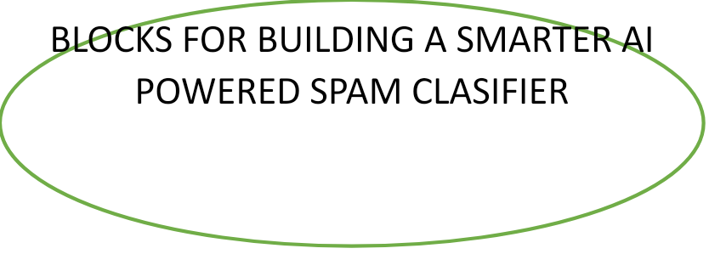





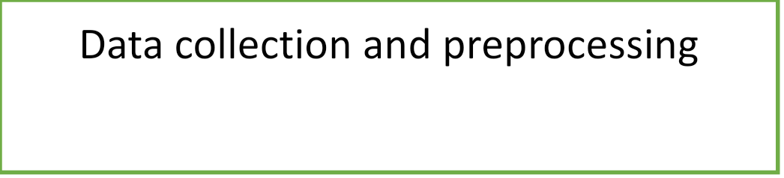



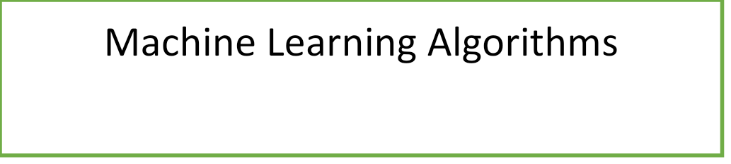





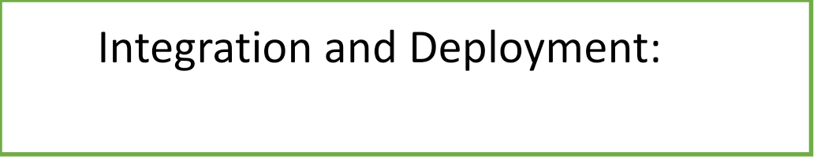



Building a smarter AI-powered spam classifier involves breaking down the process into fundamental blocks or components that collectively contribute to its intelligence and effectiveness. Here are the key building blocks for creating such a classifier:

**Data Collection and Preprocessing:**

Collect a diverse and representative dataset of labeled examples, comprising both spam and non-spam content.

Preprocess the data by cleaning, normalizing, and tokenizing text, and extracting relevant features. This block is crucial for providing the raw material for training and testing the classifier.

**Feature Engineering:**

Design and engineer relevant features that capture the distinguishing characteristics of spam content. These features may include text-based features like keywords, n-grams, and sentiment analysis scores, as well as metadata features like sender information and email headers.

**Machine Learning Algorithms:**

Implement machine learning algorithms such as logistic regression, random forests, support vector machines, or deep learning architectures like neural networks. This block involves model selection and training on the labeled dataset to create the core of the spam classifier.

**Model Evaluation Metrics:**

Define appropriate evaluation metrics, such as accuracy, precision, recall, F1-score, and receiver operating characteristic (ROC) curve, to assess the performance of the spam classifier. This block helps measure the model's effectiveness and guides improvements.

**Imbalanced Data Handling:**

Address class imbalance issues commonly found in spam classification by employing techniques like oversampling, undersampling, or generating synthetic data points. Ensuring balanced data contributes to a more accurate classifier.

**Continuous Learning and Updates:**

Develop mechanisms for continuous learning and model updates to adapt to evolving spam tactics. Regularly update the classifier with new labeled data to maintain its effectiveness over time.

**Ensemble Methods**:

Combine the predictions of multiple models using ensemble techniques such as bagging, boosting, or stacking. Ensemble methods can improve the overall performance of the spam classifier.

**User Feedback Loop:**

Establish a feedback mechanism that allows users to report false positives and false negatives. Use this feedback to fine-tune the classifier and reduce errors.

**Integration and Deployment:**

Integrate the spam classifier into user-facing communication platforms, such as email clients, messaging apps, or social media platforms. Ensure scalability, low latency, and high availability for real-time processing.

**Ethical Considerations:**

Address ethical concerns related to privacy and bias in spam classification. Implement fairness-aware algorithms and transparent decision-making processes to mitigate bias and ensure ethical use of the classifier.

**Monitoring and Maintenance:**

Continuously monitor the classifier's performance in production. Set up alerts for anomalies and maintain the system by updating dependencies, addressing issues, and ensuring data quality.

**Scalability and Efficiency:**

Design the classifier to scale efficiently as the volume of incoming data grows. Optimize resource usage to handle large datasets and high traffic loads.

**Integration of Multi-Modal Data:**

Extend the classifier's capabilities to handle various types of content, such as text, images, audio, and video. This block involves integrating multi-modal analysis techniques and feature extraction methods.

**Advanced Techniques for Zero-Day Threats:**

Implement advanced anomaly detection and behavior analysis to identify zero-day spam threats that may not be present in historical data. Utilize unsupervised learning and real-time monitoring.

These building blocks form the foundation for designing a smarter AI-powered spam classifier that can adapt to the evolving landscape of spam and provide users with a more effective and reliable protection against unwanted content. Each block plays a crucial role in creating a robust and intelligent spam detection system.

**CONCLUSION:**

Building a smarter AI-powered spam classifier is a crucial endeavor in the digital age, where email and online communication play a pivotal role in our personal and professional lives. Such a system not only helps users by reducing the annoyance of spam but also enhances overall cybersecurity. To conclude, here are key takeaways in building a smarter AI-powered spam classifier:

Data Gathering and Preprocessing: Begin by collecting a diverse and substantial dataset of both spam and non-spam (ham) emails. Preprocess the data to remove noise, perform feature extraction, and ensure it's ready for machine learning.

Feature Engineering: Develop relevant features that can help the AI model distinguish between spam and ham emails. Features might include sender information, text analysis, header analysis, and more.

Choosing the Right Algorithm: Select a suitable machine learning or deep learning algorithm for your spam classifier. Popular choices include Naive Bayes, Support Vector Machines, Random Forests, and deep neural networks like LSTM or CNN.

Model Training: Train your chosen algorithm on your preprocessed dataset. Consider using techniques like cross-validation to tune hyperparameters and avoid overfitting.

Evaluation Metrics: Assess your model's performance using appropriate evaluation metrics such as accuracy, precision, recall, F1-score, and ROC-AUC. Fine-tune the model if necessary to improve results.

Handling Imbalanced Data: Address the class imbalance issue as spam emails are often a minority class. Techniques like oversampling, undersampling, or using advanced methods like SMOTE can be beneficial.

Regular Updates: Keep your spam classifier up to date with the latest spam tactics and trends. Regularly retrain the model with new data to maintain its accuracy.

User Feedback: Incorporate user feedback into your system to continuously improve its performance. Allow users to report false positives and false negatives to enhance the model's effectiveness.

Real-time Processing: Make your spam classifier capable of processing emails in real-time to prevent spam from reaching the inbox promptly.

Scalability and Efficiency: Ensure that the AI model and infrastructure are scalable and efficient to handle large volumes of incoming emails without significant delays.

Legal and Ethical Considerations: Be aware of privacy regulations and ethical concerns when implementing your AI spam classifier, especially when handling user data.

Adaptability and Customization: Allow users to customize and fine-tune their spam filter settings according to their preferences, as what is considered spam may vary from person to person.

Continuous Improvement: Emphasize the importance of continuous research and development to stay ahead of evolving spamming techniques and AI advancements.

In conclusion, building a smarter AI-powered spam classifier requires a holistic approach, combining data, algorithms, evaluation, and user interaction. As spam tactics become more sophisticated, the development of such systems remains an ongoing and vital effort in the realm of cybersecurity and digital communication.